Exercise 3: Assertions in Junit

1. Calculator.java

package org.example;  
  
public class Calculator {  
 public int add(int a,int b){  
 return a+b;  
 }  
}

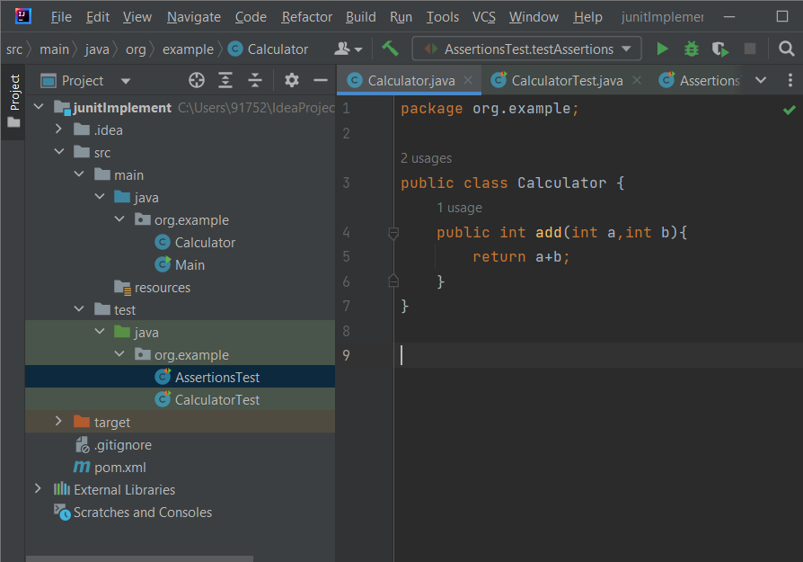

1. AssertionsTest.java
2. package org.example;  
   import org.junit.jupiter.api.Test;  
     
   import static org.junit.jupiter.api.Assertions.\*;  
   public class AssertionsTest {  
    @Test  
    public void testAssertions() {  
    // Assert equals  
    *assertEquals*(5, 2 + 3);  
     
    // Assert true  
    *assertTrue*(5 > 3);  
     
    // Assert false  
    *assertFalse*(5 < 3);  
     
    // Assert null  
    *assertNull*(null);  
     
    // Assert not null  
    *assertNotNull*(new Object());  
    }  
   }

Output-

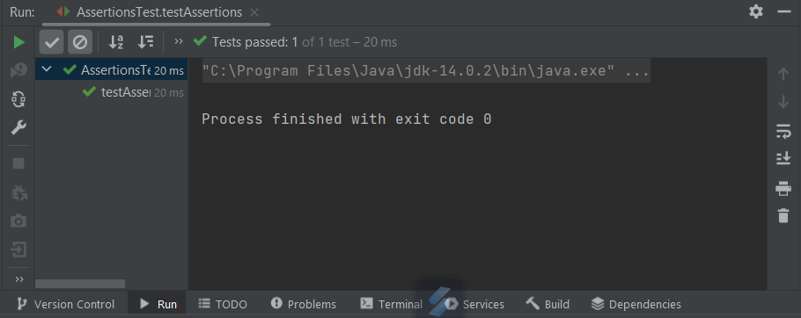

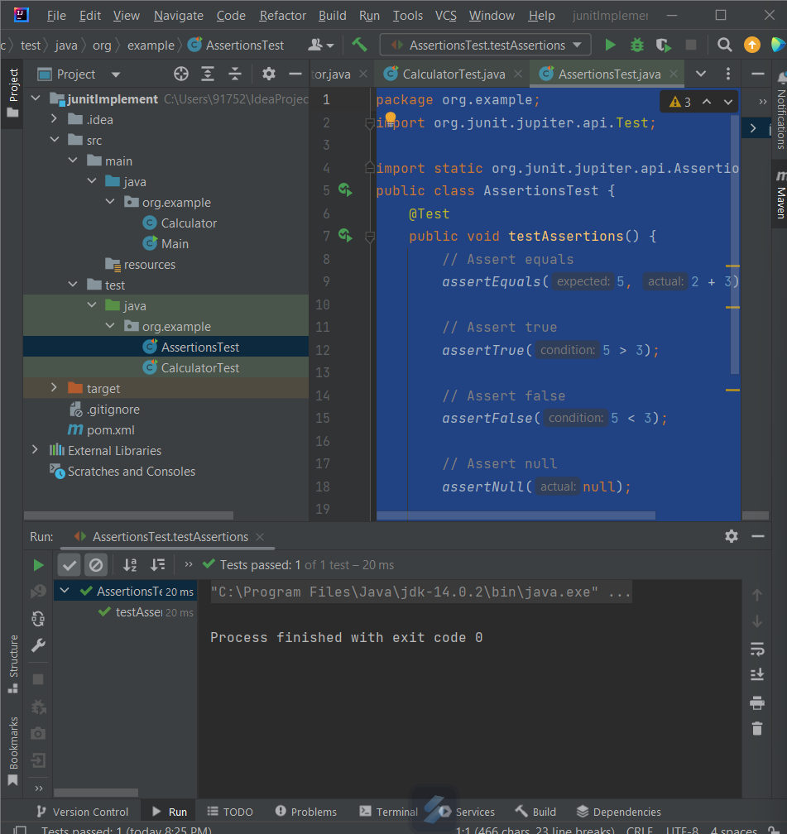

Pom.xml

<?xml version="1.0" encoding="UTF-8"?>  
<project xmlns="http://maven.apache.org/POM/4.0.0"  
 xmlns:xsi="http://www.w3.org/2001/XMLSchema-instance"  
 xsi:schemaLocation="http://maven.apache.org/POM/4.0.0 h3ttp://maven.apache.org/xsd/maven-4.0.0.xsd">  
 <modelVersion>4.0.0</modelVersion>  
  
 <groupId>org.example</groupId>  
 <artifactId>junitImplement</artifactId>  
 <version>1.0-SNAPSHOT</version>  
  
 <properties>  
 <maven.compiler.source>14</maven.compiler.source>  
 <maven.compiler.target>14</maven.compiler.target>  
 <project.build.sourceEncoding>UTF-8</project.build.sourceEncoding>  
 </properties>  
  
 <dependencies>  
 <!-- https://mvnrepository.com/artifact/org.junit.jupiter/junit-jupiter-api -->  
  
 <dependency>  
 <groupId>org.junit.jupiter</groupId>  
 <artifactId>junit-jupiter-engine</artifactId>  
 <version>5.10.0</version>  
 <scope>test</scope>  
 </dependency>  
 <dependency>  
 <groupId>junit</groupId>  
 <artifactId>junit</artifactId>  
 <version>4.13.2</version>  
 <scope>test</scope>  
 </dependency>  
  
 </dependencies>  
  
</project>

Exercise-4 - Arrange-Act-Assert(AAA) Pattern Test Fixtures, Setup and

1. Calculator.java

package org.example;  
  
public class Calculator {  
 public int add(int a,int b){  
 return a+b;  
 }  
  
 public int multiply(int a, int b) {  
 return a\*b;  
 }  
}

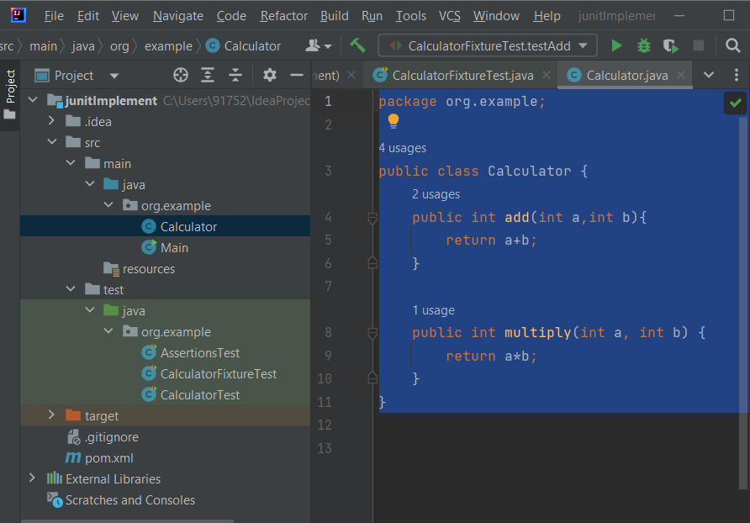

1. CalculatorFixtureTest.java
2. package org.example;  
   import org.junit.jupiter.api.\*;  
     
   import static org.junit.jupiter.api.Assertions.\*;  
   public class CalculatorFixtureTest {  
    private Calculator calculator; // ✅ Shared test object  
     
    // 🔧 Setup before every test method  
    @BeforeEach  
    void setUp() {  
    calculator = new Calculator();  
    System.*out*.println("Setup: Calculator initialized");  
    }  
     
    // 🧪 Test 1 - Using AAA pattern  
    @Test  
    void testAdd() {  
    // Arrange  
    int a = 10;  
    int b = 5;  
     
    // Act  
    int result = calculator.add(a, b);  
     
    // Assert  
    *assertEquals*(15, result);  
    }  
     
    // 🧪 Test 2  
    @Test  
    void testMultiply() {  
    // Arrange  
    int a = 3;  
    int b = 4;  
     
    // Act  
    int result = calculator.multiply(a, b);  
     
    // Assert  
    *assertEquals*(12, result);  
    }  
     
    // 🧹 Teardown after every test method  
    @AfterEach  
    void tearDown() {  
    System.*out*.println("Teardown: Test completed");  
    }  
   }

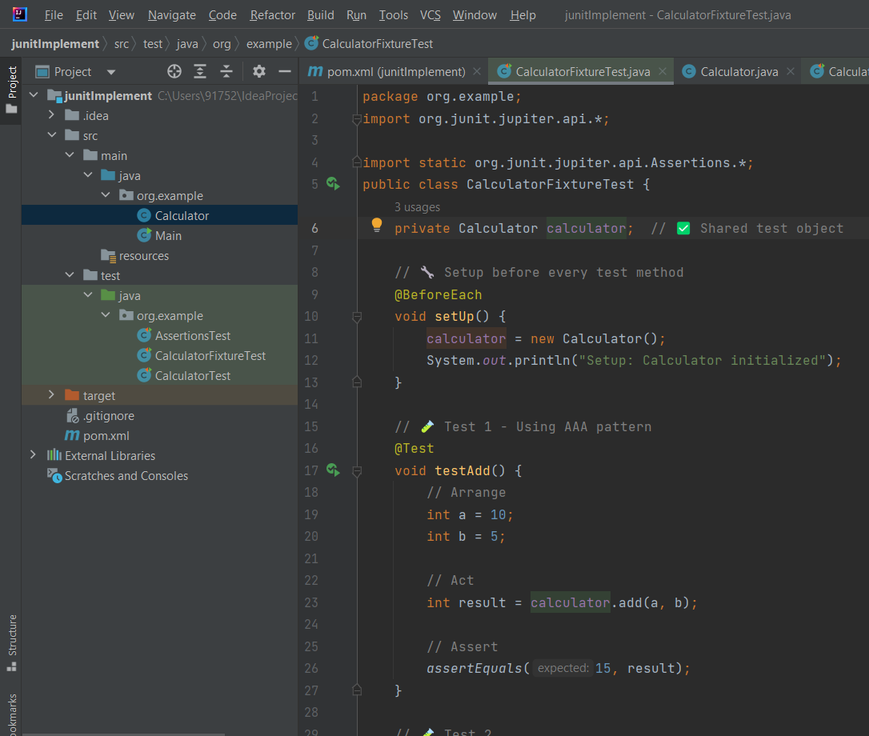

Output-

